Supplementary Table 1 Search strategy used for each database
Database | Search strategy | Records retrieved
PubMed | ("Trochanteric Fractures"[MeSH] OR "Trochanteric Fracture*" OR "Hip Fractures"[MeSH] OR "Hip Fracture*")  AND ("Intramedullary Nailing"[MeSH] OR "Intramedullary Nail*" OR "IM Nail*" OR "Nail*" OR "Gamma Nail*")  AND ("Dynamic Hip Screw"[MeSH] OR "Sliding Hip Screw*" OR "DHS" OR "Compression Hip Screw*" OR "Hip Screw*") | 317
Scopus | ALL ( ( "Trochanteric Fractures" OR "Trochanteric Fracture*" OR "Hip Fractures" OR "Hip Fracture*" ) AND ( "Intramedullary Nailing" OR "Intramedullary Nail*" OR "IM Nail*" OR "Nail*" OR "Gamma Nail*" ) AND ( "Dynamic Hip Screw" OR "Sliding Hip Screw*" OR "DHS" OR "Compression Hip Screw*" OR "Hip Screw*" ) AND ( "Intraoperative" OR "Perioperative" OR "Postoperative" OR "Surgical Outcomes" OR "Clinical Outcomes" ) ) | 2886
WOS | ("Trochanteric Fractures" OR "Trochanteric Fracture*" OR "Hip Fractures" OR "Hip Fracture*") AND ("Intramedullary Nailing" OR "Intramedullary Nail*" OR "IM Nail*" OR "Nail*" OR "Gamma Nail*") AND ("Dynamic Hip Screw" OR "Sliding Hip Screw*" OR "DHS" OR "Compression Hip Screw*" OR "Hip Screw*") AND ("Intraoperative" OR "Perioperative" OR "Postoperative" OR "Surgical Outcomes" OR "Clinical Outcomes") (All Fields) | 297
Cochrane CENTRAL | ((Trochanteric Fractures OR Trochanteric Fracture* OR Hip Fractures OR Hip Fracture*) AND (Intramedullary Nailing OR Intramedullary Nail* OR IM Nail* OR Nail* OR Gamma Nail*) AND (Dynamic Hip Screw OR Sliding Hip Screw* OR DHS OR Compression Hip Screw* OR Hip Screw*) AND (Intraoperative OR Perioperative OR Postoperative OR Surgical Outcomes OR Clinical Outcomes)):ti,ab,kw | 240
Total= 3740
Removed duplicates= 540
Title and abstract screening= 3200
Full text screening= 139
final included= 60

Supplementary Table 2 Baseline characteristics of the studies
study ID | group | N | age | BMI | Sex | Fracture classification N (%) |  |  | ASA American Society of Anesthesiologists Score N (%) |  |  | Side of fracture N (%)
study ID | group | N | mean (sd) | mean (sd) | male (N) | A1 | A2 | A3 | I | II | III | R | L
Adams 2001 | IMN | 203 | 81.2 (12.75) | - | 39 | - | - | - | - | - | - | - | -
Adams 2001 | DHS | 197 | 80.7 (17.5) | - | 49 | - | - | - | - | - | - | - | -
Adeel 2020 | PFN | 34 | 59.32 (2.39) | - | 25 | - | - | - | - | - | - | - | -
Adeel 2020 | DHS | 34 | 60.88 (12.49) | - | 22 | - | - | - | - | - | - | - | -
Ahmad 2019 | DHS | 79 | - | - | 58 | - | - | - | - | - | - | - | -
Ahmad 2019 | IMN | 6 | - | - | - | - | - | - | - | - | - | - | -
Ahrengart 2002 | IMN | 210 | 80 (12.04) | - | 61 | 33 (16%) | 73 (35%) | 31 (15%) | 33(17.2%) | 88(45.8%) | 71(37%) | - | -
Ahrengart 2002 | DHS | 216 | 79 (13.2) | - | 60 | 39( 18%) | 76 (35%) | 39 (18%) | 43(21.08%) | 84(41.18%) | 77(37.74%) | - | -
Aktselis 2014 | IMN | 36 | 82.9 (5.8) | - | 8 | - | - | - | 2(5.55%) | 20(55.55%) | 14(38.89%) | 19 (52.8%) | 17 (47.2%)
Aktselis 2014 | DHS | 35 | 83.1 (6.5) | - | 7 | - | - | - | 2(5.72%) | 27(77.14%) | 6(17.14%) | 20 (57.1%) | 15 (42.9%)
Arshad 2021 | IMN | 74 | 84 (8.89) | 24.25 | 14 | - | - | - | 1(1.85%) | 15(27.78%) | 38(70.37%) | 33 (44.59) | 41 (55.41)
Arshad 2021 | DHS | 12 | 85 (12.01) | 26.02 | 3 | - | - | - | 0 | 1(12.5%) | 7(87.5%) | 6 (50.00) | 6 (50.00)
Avakian 2011 | PFN | 51 | 82.8(9.8) | - | 16 | - | - | - | - | - | - | 21 (41%) | 30 (59%)
Avakian 2011 | DHS | 98 | 84.6(8.2) | - | 16 | - | - | - | - | - | - | 48 (49%) | 50 (51%)
Barton 2010 | IMN | 100 | 83.1 (14.25) | - | 19 | - | - | - | 0 | 47(48.96%) | 49(51.04%) | 50 (50%) | 50 (50%)
Barton 2010 | DHS | 110 | 83.3 ( 10.25) | - | 25 | - | - | - | 2(1.87%) | 46(42.99%) | 59(55.14%) | 48 (44%) | 62 (56%)
Berney 2024 | DHS | 2371 | 81.3 (8.9) | - | 739 | - | - | - | - |  | 1222 (51.5%) | - | -
Berney 2024 | IMN | 3297 | 81.9 (8.7) | - | 899 | - | - | - | - |  | 1703 (51.7%) | - | -
Butt 1995 | IMN | 47 | 79 (9.25 ) | - | 16 | - | - | - | - | - | - | - | -
Butt 1995 | DHS | 48 | 78 (13.5) | - | 13 | - | - | - | - | - | - | - | -
Carruli 2017 | PFN | 71 | 81.62 ( 7.82) | - | 29 | 25 (35.21%) | 46 (64.69%) | - | - | - | - | - | -
Carruli 2017 | DHS | 69 | 83.41 ( 7.90) | - | 25 | 28 (40.57%) | 41 (59.43%) | - | - | - | - | - | -
Chau 2013 | PFN | 25 | 75.5 (3.5) | - | 13 | - | 16 (64%) | 9 (36%) | - | - | - | 10 (40%) | 15 (60%)
Chau 2013 | DHS | 38 | 77 (1.75) | - | 18 | - | 34 (89%) | 2 (11%) | - | - | - | 17 (45%) | 21 (55%)
Chen 2013 | IMN | 1993 | 83 (8.9) | - | 426 | - | - | - | - | - | - | - | -
Chen 2013 | DHS | 6931 | 84 (8.3) | - | 1349 | - | - | - | - | - | - | - | -
Das 2020 | IMN | 75 | 68.6 (6.25) | - | 21 | - | 35 (46.66%) | 40 (53.33%) | - | - | - | 25 (33%) | 50 (67%)
Das 2020 | DHS | 75 | 68.8 (8.25) | - | 27 | - | 37 (49.33%) | 38 (50.66%) | - | - | - | 35 (47%) | 40 (53%)
Duan 2017 | DHS | 62 | 75.5 | - | - | - | - | - | - | - | - | - | -
Duan 2017 | IMN | 46 | 75.5 | - |  |  |  |  | - | - | - | - | -
Dunne 2021 | DHS | 741 | 82.5 (10.5) | - | 204 | - | 560 (76%) | - | - | - | - | - | -
Dunne 2021 | IMN | 594 | 82.6 (9.4) | - | 176 | - | 471 (79%) | - | - | - | - | - | -
Gawronska 2022 (Aug) | GMN | 20 | 75.95 (8.88) | 26.27(3.47) | - | - | - | - | - | - | - | - | -
Gawronska 2022 (Aug) | DHS | 20 | 73.8 (8.95) | 25.72(3.06) | - | - | - | - | - | - | - | - | -
Gawronska 2022 (Feb) | BOTH | 78 | (range 29–104) | - | - | - | - | - | - | - | - | - | -
Grezda 2021 | DHS | 20 | 78.4 (6.9) | 26.7 (4.2) | 6 | 11 (55%) | 9 (45%) | - | - | - | - | - | -
Grezda 2021 | IMN | 20 | 77.75 (7.0) | 25.3 (3.8) | 5 | 13 (65%) | 7 (35%) | - | - | - | - | - | -
Hardy 1998 | IMN | 50 | 81.7 (11.8) | - | 42 | - | - | - | - | - | - | - | -
Hardy 1998 | DHS | 50 | 79.5 (10.7) | - | 35 | - | - | - | - | - | - | - | -
Harrington 2002 | IMN | 50 | 83.8 (8.5) | - | 10 | - | - | 13 (26%) | 3(7.32%) | 22(53.66%) | 16(39.02%) | - | -
Harrington 2002 | DHS | 52 | 82.1 ( 8.6) | - | 11 | - | - | 15 (28.84%) | 4(9.76%) | 20(48.78%) | 17(41.46%) | - | -
Hoffman 1996 | IMN | 31 | 83.2 ( 8.1 ) | - | 4 | - | - | - | - | 10(40%) | 15(60%) | - | -
Hoffman 1996 | DHS | 36 | 79.0 (10.4) | - | 12 | - | - | - | - | 18(54.55%) | 15(45.45%) | - | -
Huang 2017 | IMN | 30 | 75.07 (7.87) | - | 15 | - | - | - | - | - | - | - | -
Huang 2017 | DHS | 30 | 74.01 ( 7.25) | - | 17 | - | - | - | - | - | - | - | -
Kassem 2022 | DHS | 34 | 68.7 (8.7) | - | 32 | - | 34 (100%) | - | 12 (35.2%) | 18 (52.9%) | 4 (11.7%) | 12 (35%) | -
Kassem 2022 | IMN | 34 | 70.8 (7.7) | - | - | - | 34 (100%) | - | 16 (47%) | 14 (41.1%) | 4 (11.7%) | 20 (59%) | -
Kim 2020 | IMN | 67 | 63.5 ( 2.18) | 22.0 (3.8) | 23 | - | - | - | - | - | - | - | -
Kim 2020 | DHS | 39 | 76.4 (7.9) | 21.4 (3.2) | 16 | - | - | - | - | - | - | - | -
Kim 2022 | CMN | 68 | 47(12.5) | - | 29 | - | - | - | - | - | - | - | -
Kim 2022 | DHS | 16 | 73.75(13) | - | 7 | - | - | - | - | - | - | - | -
Kleftouris 2023 | IMN | 29 | 85.7 ( 5.5) | - | 6 | - | - | - | - | 8(33.33%) | 16(66.67%) | - | -
Kleftouris 2023 | DHS | 28 | 84.1 ( 9.1) | - | 5 | - | - | - | - | 9(32.14%) | 19(67.86%) | - | -
Konda 2021 | SHORT CMN | 213 | 86.5(7.5) | - | 67 | - | - | - | - | - | - | - | -
Konda 2021 | SHS | 16 | 87.6(7.1) | - | 7 | - | - | - | - | - | - | - | -
Kumar 2011 | PFN | 25 | > 50 | - | - | 1(4%) | 13(52%) | 9(36%) | - | - | - | - | -
Kumar 2011 | DHS | 25 | > 50 | - | - | 11(44%) | 14(53%) | 0 | - | - | - | - | -
Little 2008 | IMN | 92 | 82.6(12) | - | 8 | 15 (16.3%) | 38 (41.3%) | 39 (42.4%) | 2(2.17%) | 57(61.96%) | 33(35.87%) | 45 (48.9%) | 47 (51.1%)
Little 2008 | DHS | 98 | 84.2 (12) | - | 20 | 29 (29.6%) | 51 (52.0%) | 18 (18.4%) | 3(3.16%) | 55(57.89%) | 37(38.95%) | 47(48%) | 51 (52.0%)
Marks 2021 | CMN | 10436 | 85.7(6.7) | - | 2681 | - | - | - | 111(1.17%) | 2209(23.28%) | 7170(75.55%) | - | -
Marks 2021 | SHS | 396 | 84.9(6.1) | - | 122 | - | - | - | 6(5.13%) | 69(58.97%) | 42(35.90%) | - | -
Mazzola 2022 | DHS | 44 | 83.7 (10.3) | - | 9 | 44 (100%) | - | - | 12 (27.2%) | 19 (43.1%) | 12 (27.2%) | - | -
Mazzola 2022 | IMN | 41 | 86.6 (7.4) | - | 6 | 41 (100%) | - | - | 9 (21.9%) | 18 (43.9%) | 12 (29.2%) | - | -
Pajarinen 2004 | IMN | 24 | 78.8 ( 9.7) | - | 4 | - | - | - | - | - | - | - | -
Pajarinen 2004 | DHS | 24 | 79.8 ( 10.2) | - | 5 | - | - | - | - | - | - | - | -
Pajarinen 2005 | IMN | 54 | 80.9 (9.1) | 21.4 (3) | 13 | 21( 38.9%) | 26 (48.1%) | - | - | 6(17.65%) | 28(82.35%) | - | -
Pajarinen 2005 | DHS | 54 | 80.3 (10.8) | 22.3 (3.6) | 14 | 16 (48.2%) | 24 (44.4%) | - | - | 8(20%) | 32(80%) | - | -
Parker 2012 | IMN | 300 | 82.4 (19.5) | - | 52 | - | - | - | - | - | - | - | -
Parker 2012 | DHS | 300 | 81.4 (19.25) | - | 69 | - | - | - | - | - | - | - | -
Parker 2017 | IMN | 500 | 82.2 | - | 112 | 87 (17.4%) | 353 (70.6%) | 47 (9.4%) | - |  | - | - | -
Parker 2017 | SHS | 500 | 82.1 | - | 116 | 83 (16.6%) | 364 (73.0%) | 42 (8.4%) | - |  | - | - | -
Parker-Cawley 2017 | IMN | 200 | 82(16.25) | - | 60 | 38 (19.0%) | 141 (70.5%) | 17 (8.5%) | - |  | - | - | -
Parker-Cawley 2017 | DHS | 200 | 83.25(20) | - | 47 | 27 (13.5%) | 156 (78.0%) | 14 (7.0%) | - |  | - | - | -
Pehli̇Vanoğlu 2021 | PFN | 57 | 74.7(10) | - | 21 | - | - | - | - | - | - | 29 (50.87%) | 28 (49.12%)
Pehli̇Vanoğlu 2021 | DHS | 65 | 72(9.9) | - | 31 | - | - | - | - | - | - | 36 (55.38%) | 29 (44.61%)
Reindl 2015 | IMN | 102 | 82 (8.6) | - | 57 | - | - | - | - | - | - | - | -
Reindl 2015 | DHS | 92 | 80 (9.9) | - | 31 | - | - | - | - | - | - | - | -
Saarenpää 2006 | DHS | 15 | 73.9 (8.0) | - | 3 | - | - | - | - | - | - | - | -
Saarenpää 2006 | IMN | 43 | 75.9 (9.0) | - | 13 | - | - | - | - | - | - | - | -
Sadowski 2002 | IMN | 20 | 80 ( 13) | - | 7 | - | - | 20 (100%) | 0 | 6(35.29%) | 11(64.71%) | - | -
Sadowski 2002 | DHS | 19 | 77 ( 14) | - | 5 | - | - | 19 (100%) | 1(5.26%) | 9(47.37%) | 9(47.37%) | - | -
Sahin 2012 | PFN | 95 | 70.3 (4.4) | - | 44 | 44 (44.89%) | 41 (41.83%) | 14 (14.28%) | - | - | - | - | -
Sahin 2012 | DHS | 86 | 72.4 (3.3) | - | 37 | 39 (45.34%) | 31 (36.04%) | 19 (22.09%) | - | - | - | - | -
Saleem 2020 | DHS | 54 | 60.2 (11.37) | - | 37 | - | - | - | - | - | - | 36 (66.7%) | 18 (33.3%)
Saleem 2020 | IMN | 54 | 58.54 (11.43) | - | 31 | - | - | - | - | - | - | 33 (61.1%) | 21 (38.9%)
Sanders 2017 | IMN | 123 | 80.6(0.8) | 24.6(0.6) | 36 | 21 (17%) | 102 (83%) | - | - | - | - | 55 (45%) | 68 (55%)
Sanders 2017 | DHS | 126 | 81.0(0.8) | 23.4(0.6) | 33 | 22 (18%) | 104 (82%) | - | - | - | - | 64 (51%) | 62 (49%)
Saudan 2002 | IMN | 100 | 83 ( 9.7) | - | 24 | - | - | - | 1(1.06%) | 30(31.91%) | 63(67.02%) | - | -
Saudan 2002 | DHS | 106 | 83.7 (10.1) | - | 22 | - | - | - | 3(3.03%) | 30(30.30%) | 66(66.67%) | - | -
Schemitsch 2023 | IMN | 418 | 78.2 | 23.4 (4.2) | 153 | 210 (50.23%) | 207 (49.52%) | - | 33 (7.9%) | 175 (42.1%) | 182 (43.8%) | - | -
Schemitsch 2023 | SHS | 415 | 78.8 | 23.6 (4.4) | 138 | 216 (50%) | 198 (47.71%) | - | 33 (8.0%) | 144 (35.0%) | 215 (52.2%) | - | -
Singh 2019 | IMN | 30 | 72.76 ( 9.5) | - | 9 | 22 (73.3%) | 8 (26.7%) | - | 20(66.67%) | 8(26.67%) | 2(6.67%) | - | -
Singh 2019 | DHS | 30 | 69.33 ( 5.7) | - | 16 | 20 (66.7%) | 10 (33.3%) | - | 23(76.67%) | 6(20%) | 1(3.34%) | - | -
Talmac 2019 | PFN | 45 | 73.9(4.6) | 30.2(4.2) | 20 | - | - | - | 7 (15.6%) | 18 (40%) | 20 (44.4%) | 23(51.1%) | 22(48.9%)
Talmac 2019 | DHS | 42 | 70.6(5.4) | 29.6(4.8) | 25 | - | - | - | 11 (26.2%) | 11 (26.2%) | 20 (47.6%) | 16(38.1%) | 26(61.9%)
tarantino 2005 | GMN | 71 | 71(13.8) | - | 22 | - | - | - | - | - | - | 38(53.5%) | -
tarantino 2005 | DMS | 71 | 70.4(13.2) | - | 22 | - | - | - | - | - | - | 42(59.2%) | -
Tian 2022 | DHS | 46 | 71.37 (6.22) | 24.82 (3.71) | 22 | 16 (34.7%) | 19 (41.3%) | 11 (23.9%) | - | - | - | 30(65.2%) | 16(34.8%)
Tian 2022 | IMN | 52 | 73.45 (5.95) | 25.45 (3.47) | 22 | 22 (42.3%) | 20 (38.4%) | 10 (19.2%) | - | - | - | 32(61.5%) | 20(38.5%)
Utrilla 2005 | IMN | 104 | 80.6 (7.5) | - | 38 | - | - | - | 13(13.98%) | 39(41.93%) | 41(44.09%) | - | -
Utrilla 2005 | DHS | 106 | 79.8 ( 7.3) | - | 28 | - | - | - | 14(13.59%) | 35(33.98%) | 54(52.43%) | - | -
Warren 2019 | IMN | 8505 | 80.31(10.93) | 24.69(5.66 | 2576 | - | - | - | - |  | - | - | -
Warren 2019 | DHS | 8505 | 80.01(11.13) | 24.69(5.66) | 2643 | - | - | - | - |  | - | - | -
Werner 2015 | DHS | 11781 | - | - | 3152 | - | - | - | - | - | - | - | -
Werner 2015 | IMN | 22978 | - | - | 6036 | - | - | - | - | - | - | - | -
Xu 2010 | IMN | 51 | 78.5 ( 7.97 ) | - | 15 | - | - | - | 12(27.27%) | 22(50%) | 10(22.73%) | - | -
Xu 2010 | DHS | 55 | 77.9 ( 7.82) | - | 16 | - | - | - | 14(30.43%) | 21(45.65%) | 11(23.91%) | - | -
Yeganeh 2016 | IMN | 60 | 66.68 ( 2.13) | - | - | - | 30 (21.4%) | 16 (11.4%) | - | - | - | - | -
Yeganeh 2016 | DHS | 54 | 63.5 ( 2.18) | - | - | - | 27 (19.2% | 14 (10%) | - | - | - | - | -
Yu 2016 | IMN | 110 | 72.02 ( 6.500) | 30.64 (1.350) | 51 | 110 (100%) | - | - | 36(46.75%) | 12(15.58%) | 29(37.66%) | - | -
Yu 2016 | DHS | 112 | 73.05 ( 7.48) | 31.03 ( 2.19) | 57 | 112 (100%) | - | - | 29(38.67%) | 13(17.33%) | 33(44%) | - | -
Zang 2018 | PFN | 50 | 61.81(6.57) | - | 27 | - | - | - | - | - | - | - | -
Zang 2018 | DHS | 50 | 61.26(6.29) | - | 29 | - | - | - | - | - | - | - | -
Zehir 2015 | IMN | 96 | 77.22 ( 6.82) | - | 37 | - | 96 (100%) | - | 0 | 14(26.42%) | 39(73.58%) | 53 (55.2 %) | 43 (44.8%)
Zehir 2015 | DHS | 102 | 76.86 ( 6.74) | - | 39 | - | 102 (100%) | - | 0 | 14(20.59%) | 54(79.41%) | 57 (55.9 %) | 45 (44.1%)
zeng 2017 | IMN | 110 | 74.34 ( 8.18) | 24.94 ( 1.99) | 70 | 32 (29.1%) | 48 (43.63%) | 30 (27.27%) | 32(32.65%) | 36(36.73%) | 30(30.61%) | - | -
zeng 2017 | DHS | 112 | 75.16 ( 8.80) | 25.34 ( 1.38) | 67 | 36 (32.14%) | 42 (37.5%) | 34 (30.35%) | 27(27.55%) | 39(39.80%) | 32(32.65%) | - | -
Zou 2009 | IMN | 58 | 65 (13.5) | - | 36 | - | - | - | - | - | - | - | -
Zou 2009 | DHS | 63 | 65 (13.75) | - | 38 | - | - | - | - | - | - | - | -

Supplementary Table 3 Quality assessment of the included Cohort studies
study ID |  | selection |  |  |  | Comparability | outcome |  |  | overall assesment
study ID |  | Representativeness of the exposed cohort | Selection of the non-exposed cohort | Ascertainment of exposure | Demonstration that outcome of interest was not present at start of study | Comparability of cohorts on the basis of the design or analysis controlled for confounders | Assessment of outcome | Was follow-up long enough for outcomes to occur | Adequacy of follow-up of cohorts | overall assesment
Ahmad 2019 |  | * | * | * | * | * | - | * | - | Fair
Chau 2013 |  | * | * | * | * | * | * | * | * | Good
Gawronska 2022 (Aug) |  | * | * | * | * | * | * | * | * | Good
Gawronska 2022 (Feb) |  | * | * | * | * | ** | * | * | * | Good
Grezda 2021 |  | * | * | * | * | ** | * | - | * | Good
Kumar 2011 |  | * | * | * | * | * | * | * | * | Good
Tarantino 2005 |  | * | * | * | * | ** | * | * | * | Good
Arshad 2021 |  | * | * | * | * | * | * | - | * | Good
Avakian 2011 |  | * | * | * | * | ** | * | * | * | Good
Berney 2024 |  | * | * | * | * | ** | - | * | * | Good
Chen 2013 |  | * | * | * | * | * | * | * | - | Good
Duan 2017 |  | * | * | * | * | * | * | * | * | Good
Dunne 2021 |  | * | * | * | * | ** | * | * | * | Good
Kim 2020 |  | * | * | * | * | * | * | * | * | Good
Kim 2022 |  | * | * | * | * | ** | * | * | * | Good
Konda 2021 |  | * | * | * | * | ** | * | * | * | Good
Marks 2021 |  | * | * | * | * | ** | * | * | * | Good
Mazzola 2022 |  | * | * | * | * | ** | * | * | * | Good
Pehli̇vanoğlu 2021 |  | * | * | * | * | ** | * | * | * | Good
Talmac 2019 |  | * | * | * | * | ** | * | * | * | Good
Tian 2022 |  | * | * | * | * | ** | * | * | * | Good
Warren 2019 |  | * | * | * | * | * | * | - | * | Good
Werner 2015 |  | * | - | * | - | - | * | * | * | Fair
Yeganeh 2016 |  | * | * | * | * | * | * | - | * | Good
Yu 2016 |  | * | * | * | * | * | * | * | * | Good
Zang 2018 |  | * | * | * | * | ** | * | * | * | Good
Zeng 2017 |  | * | * | * | * | * | * | * | * | Good
Saarenpää 2006 |  | * | * | * | * | ** | * | * | * | Good
Sahin 2012 |  | * | - | * | - | * | * | * | * | Fair

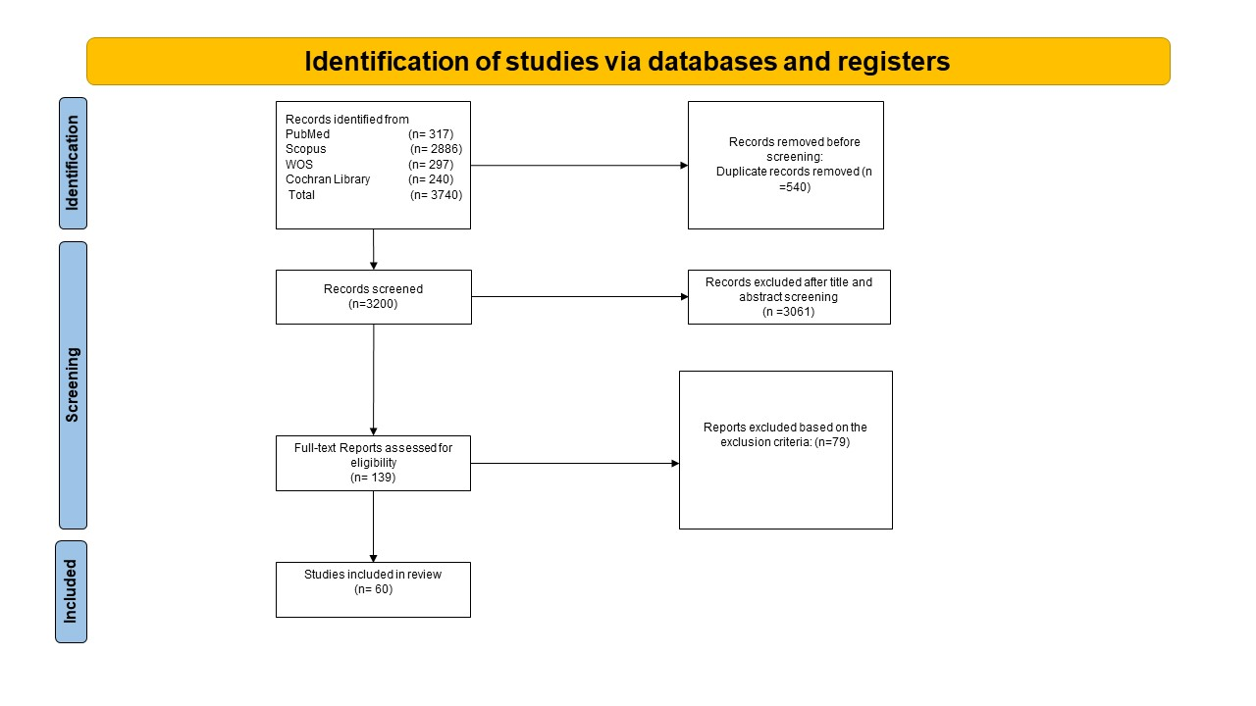
Supplementary Figure 1 PRISMA flow diagram

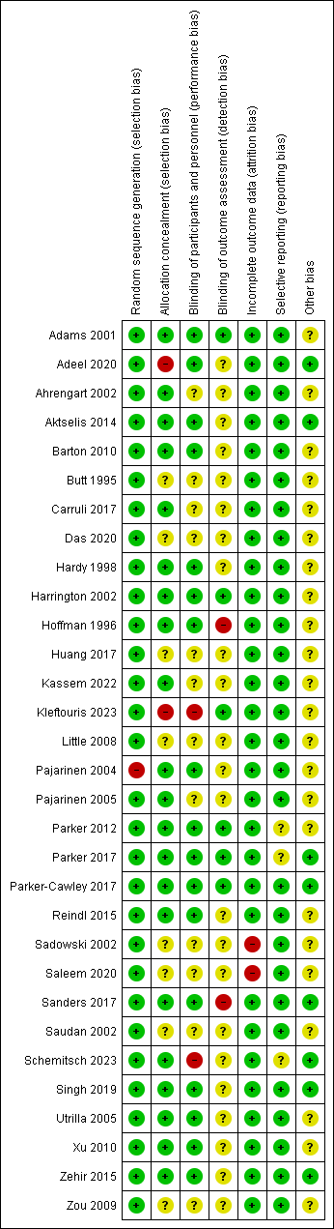
Supplementary Figure 2 The quality assessment of the included RCTs

Subgroup analysis:

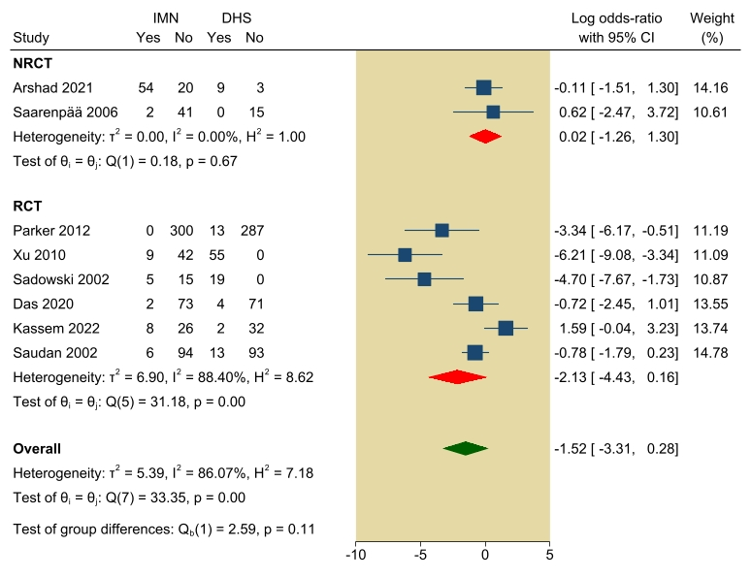
Supplementary Figure 3 open reduction of fracture
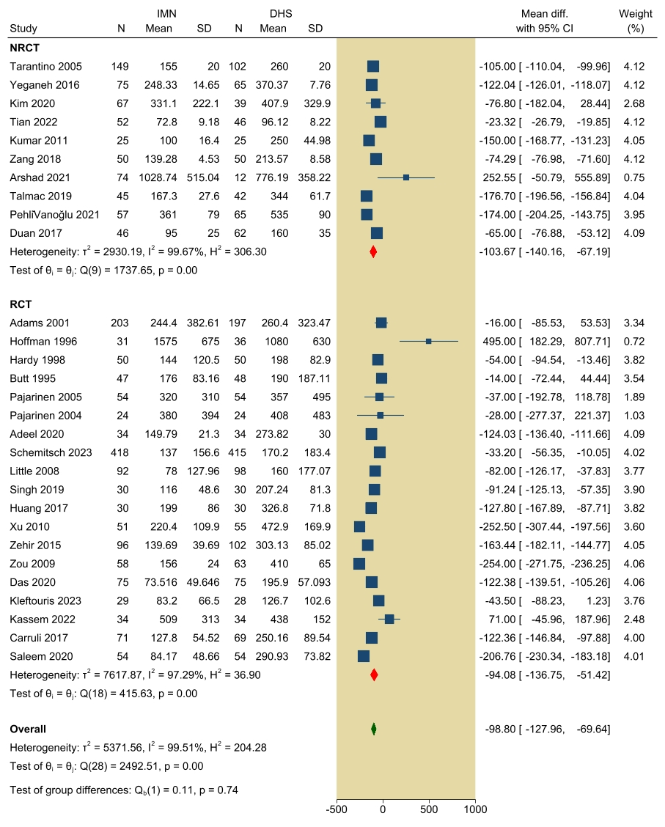
Supplementary Figure 4 Blood lose ml

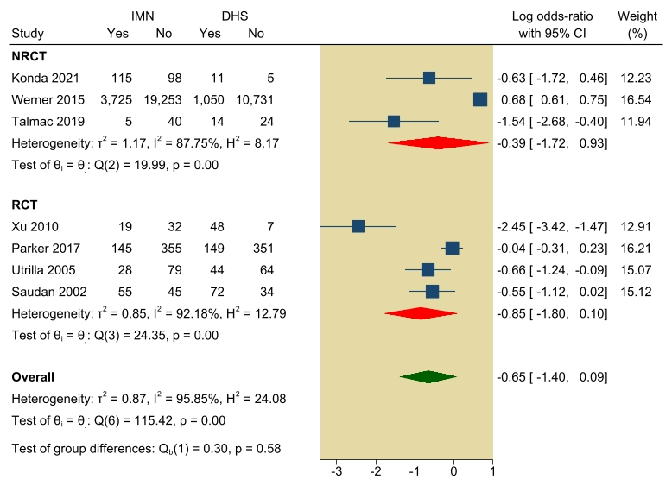
Supplementary Figure 5 Patients need Blood transfusion

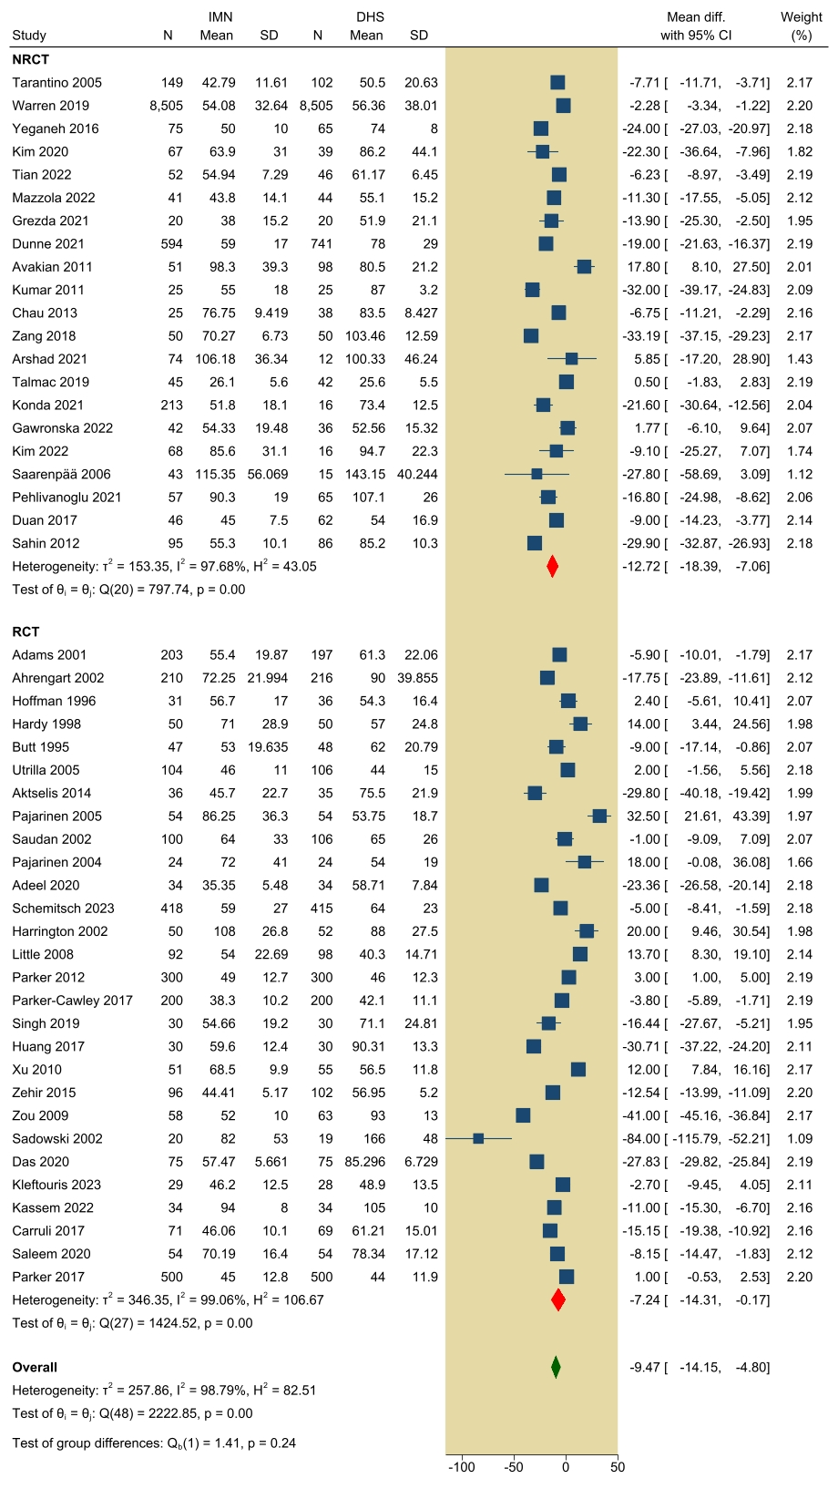
Supplementary Figure 6 mean surgical time (min)
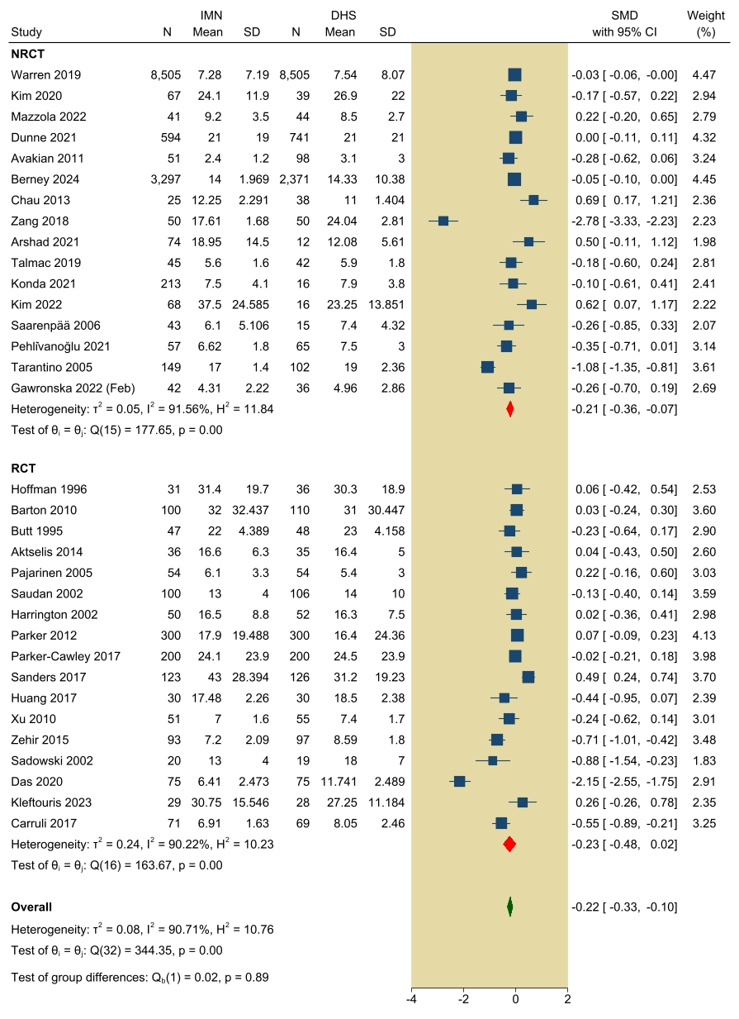
Supplementary Figure 7 hospital stay (days)

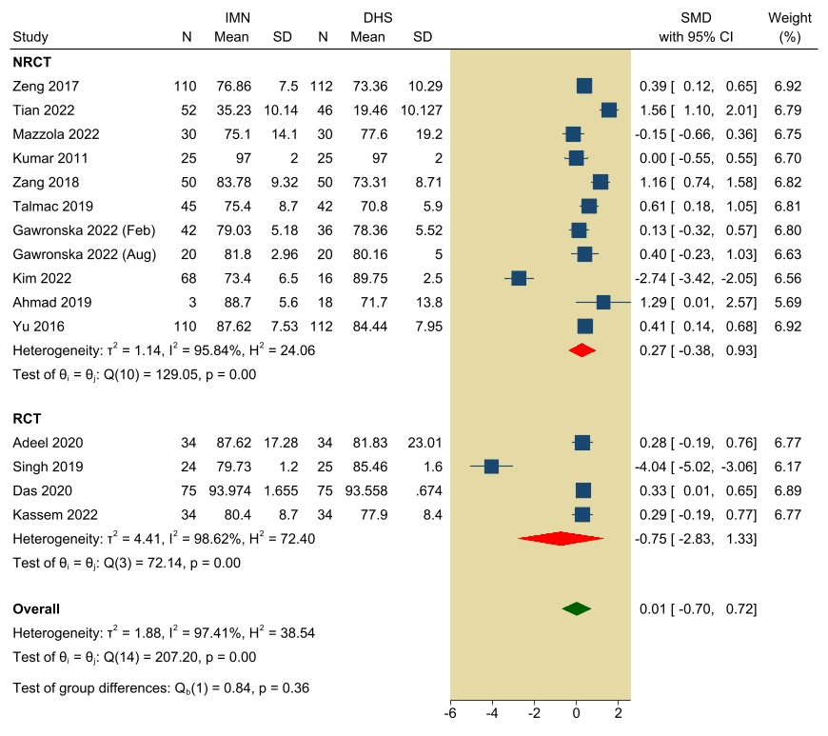
Supplementary Figure 8 mean Harris hip score
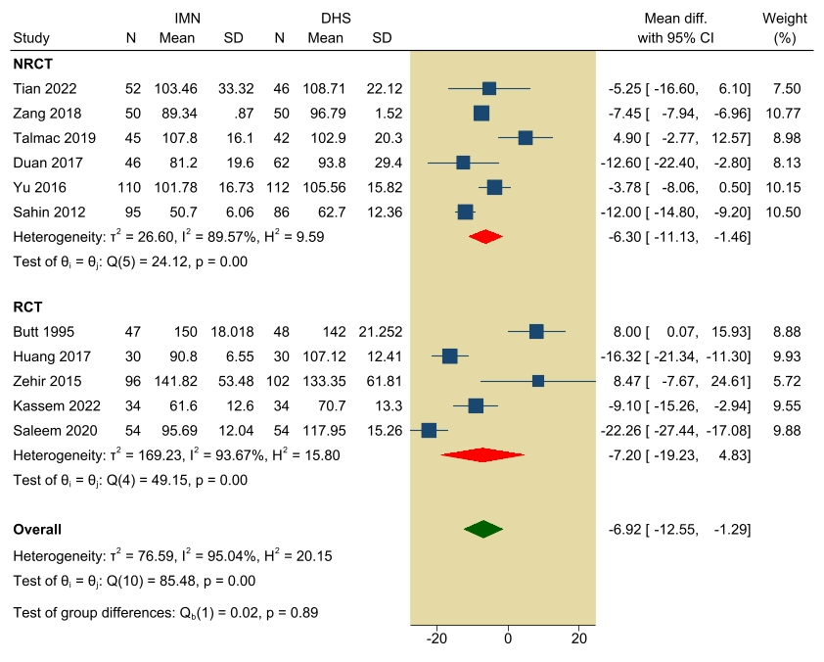
Supplementary Figure 9 time to healing (days)

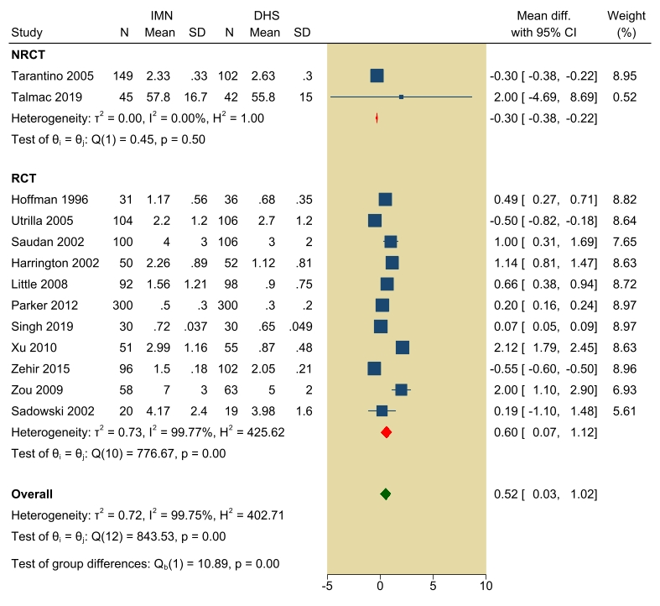
Supplementary Figure 10 screening time (min)

Sensitivity analysis
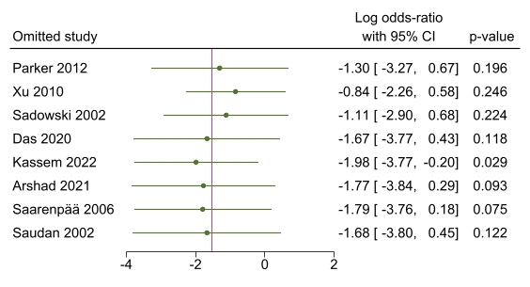
Supplementary Figure 11 open reduction of fracture

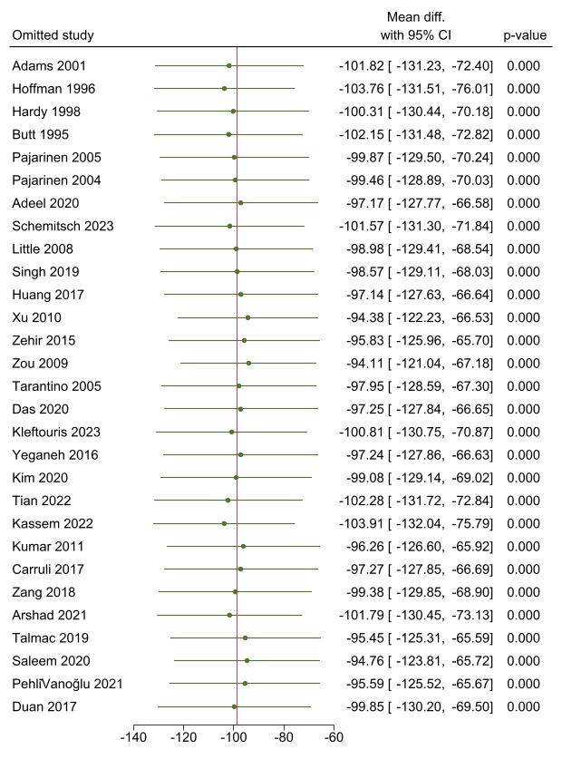
Supplementary Figure 12 Blood lose ml

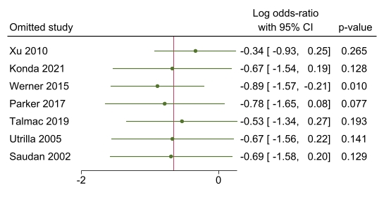
Supplementary Figure 13 Patients need Blood transfusion

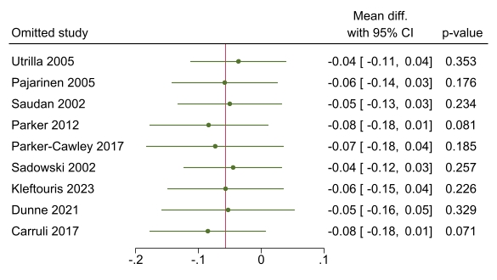
Supplementary Figure 14 required blood transfusion (UNITS)

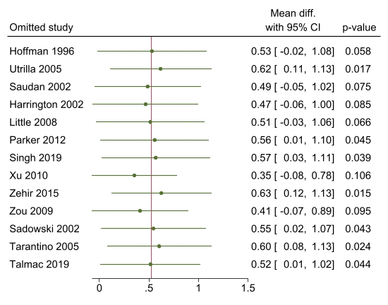
Supplementary Figure 15 screening time (min)

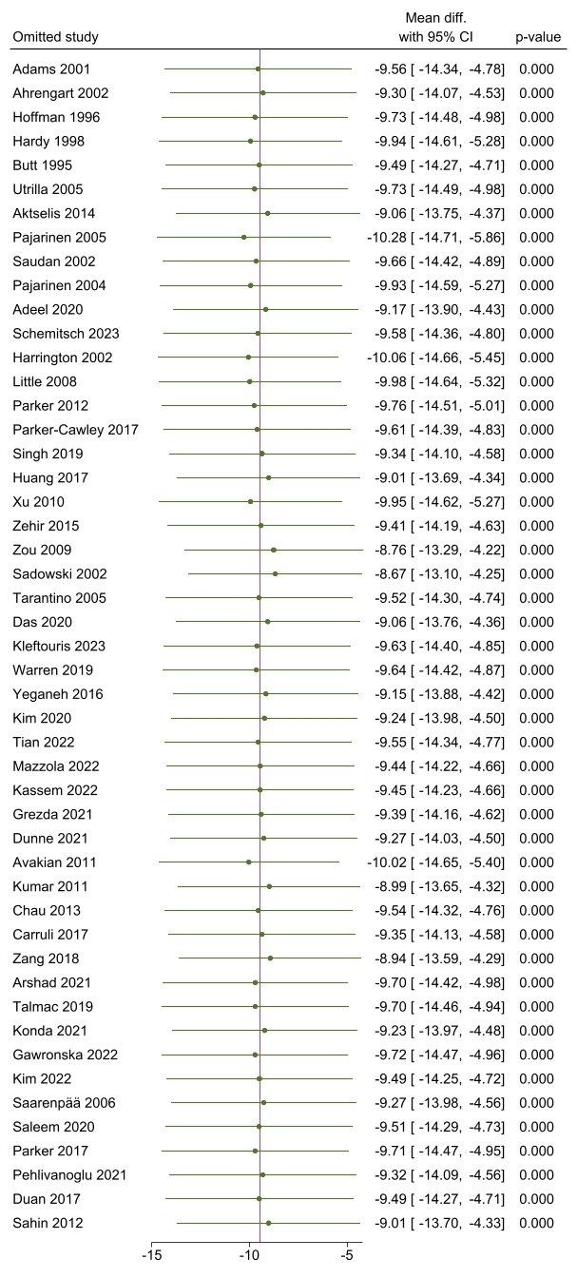
Supplementary Figure 16 mean surgical time (min)
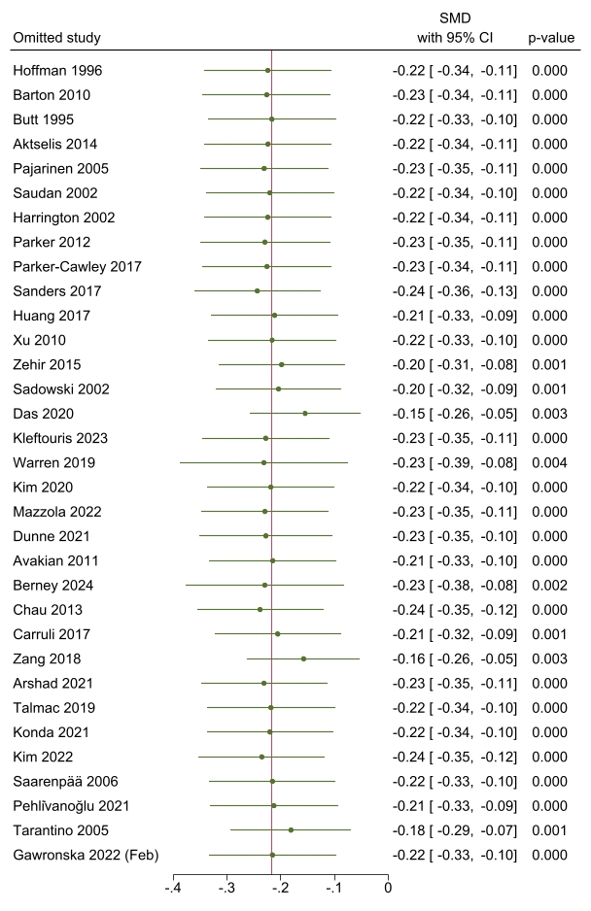
Supplementary Figure 17 hospital stay (days)

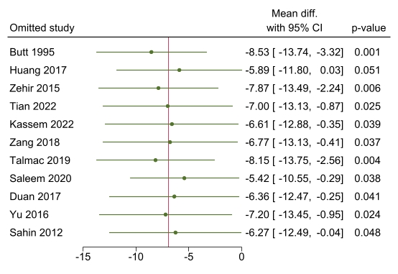
Supplementary Figure 18 time to healing (days)

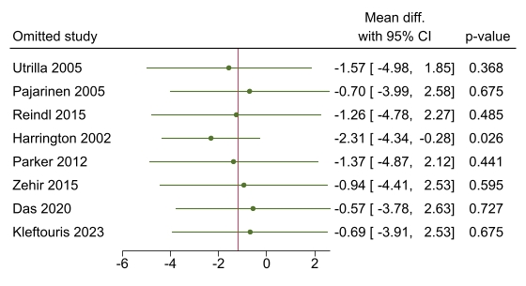
Supplementary Figure 19 femoral neck shortening (mm)

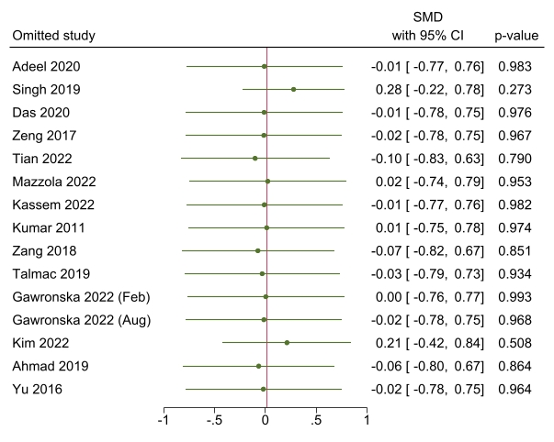
Supplementary Figure 20 mean Harris hip score
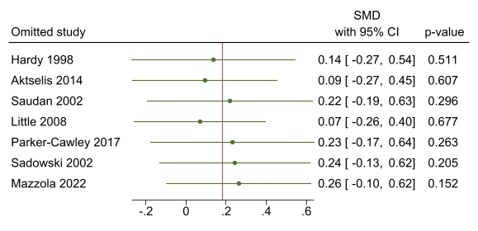
Supplementary Figure 21 Parker Mobility Score

