Cumulative analysis
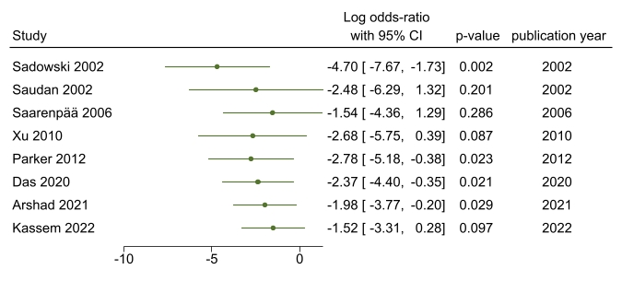
Supplementary Figure 1 open reduction of fracture

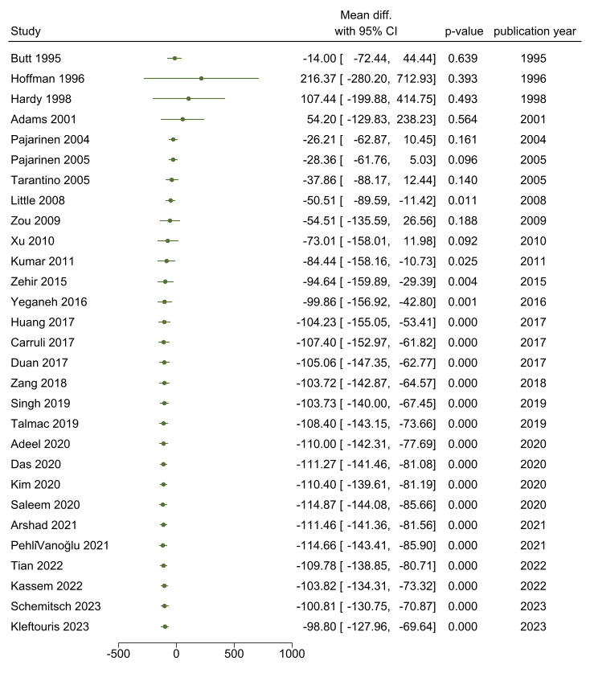
Supplementary Figure 2.Blood lose ml

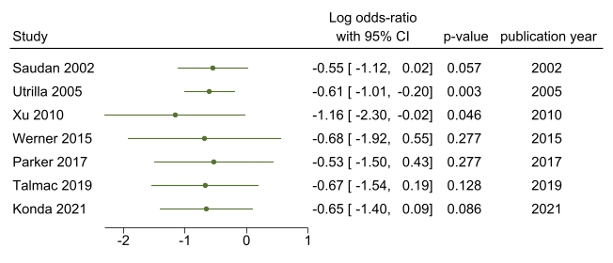
Supplementary Figure 3 Patients need Blood transfusion

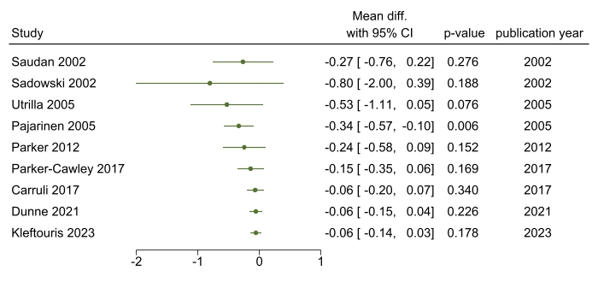
Supplementary Figure 4 required blood transfusion (UNITS)

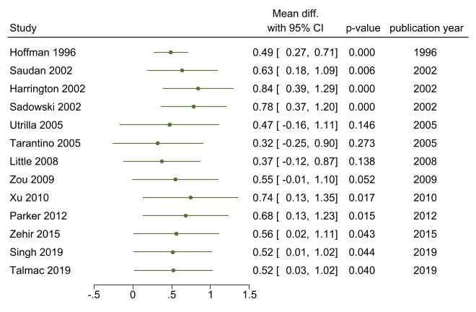
Supplementary Figure 5 screening time (min)

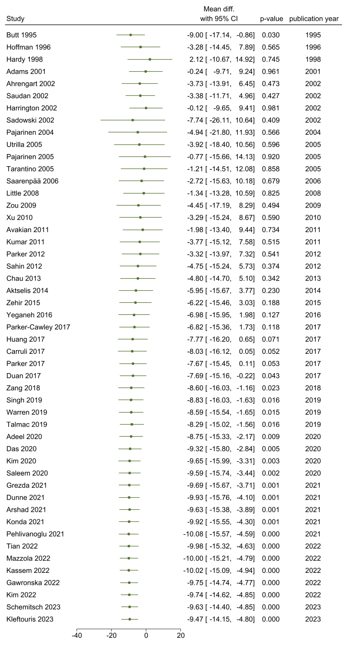
Supplementary Figure 6 mean surgical time (min)

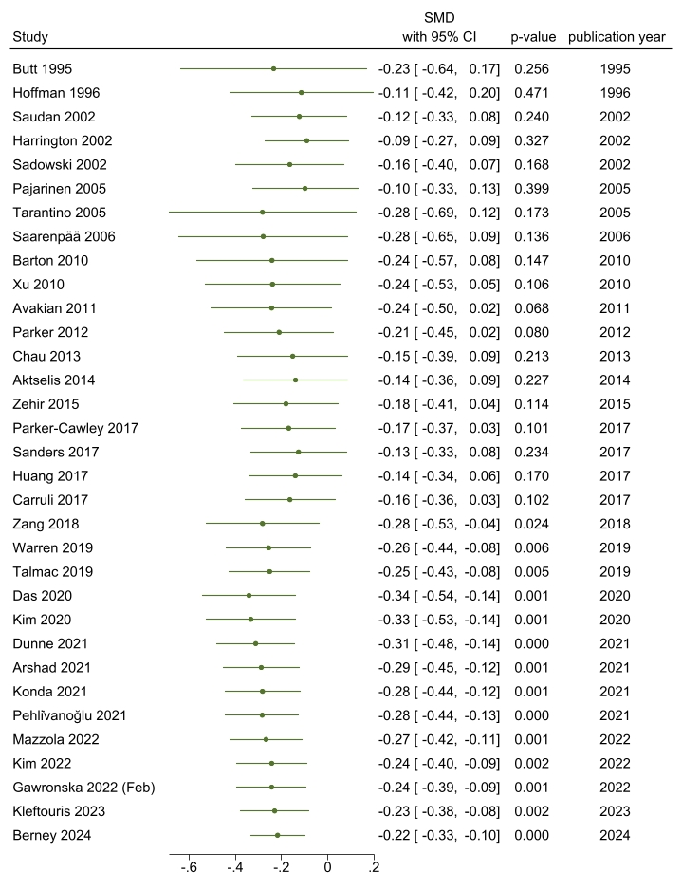
Supplementary Figure 7 hospital stay (days)

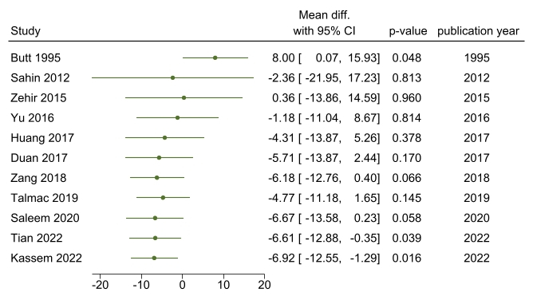
Supplementary Figure 8 time to healing (days)

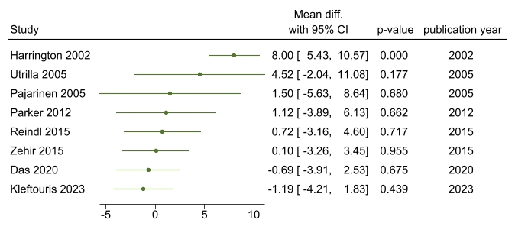
Supplementary Figure 9 femoral neck shortening (mm)

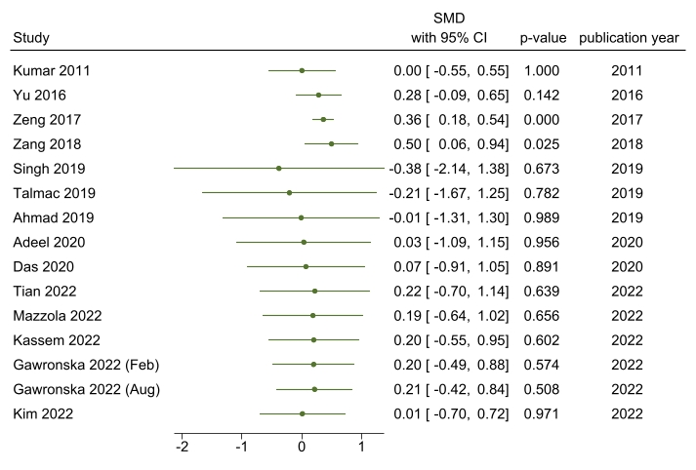
Supplementary Figure 10 mean Harris hip score

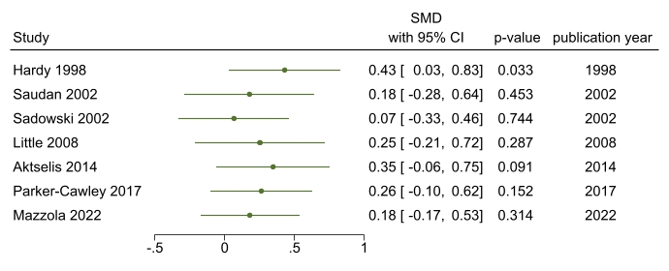
Supplementary Figure 11 Parker Mobility Score

Trial Sequential Analysis (TSA)

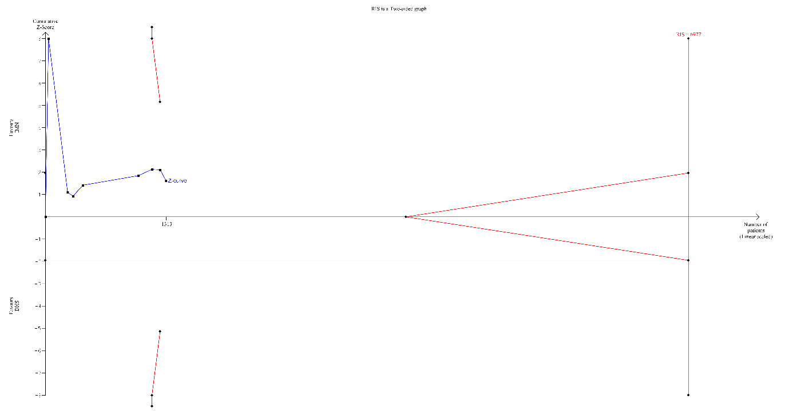
Supplementary Figure 12 open reduction of fracture

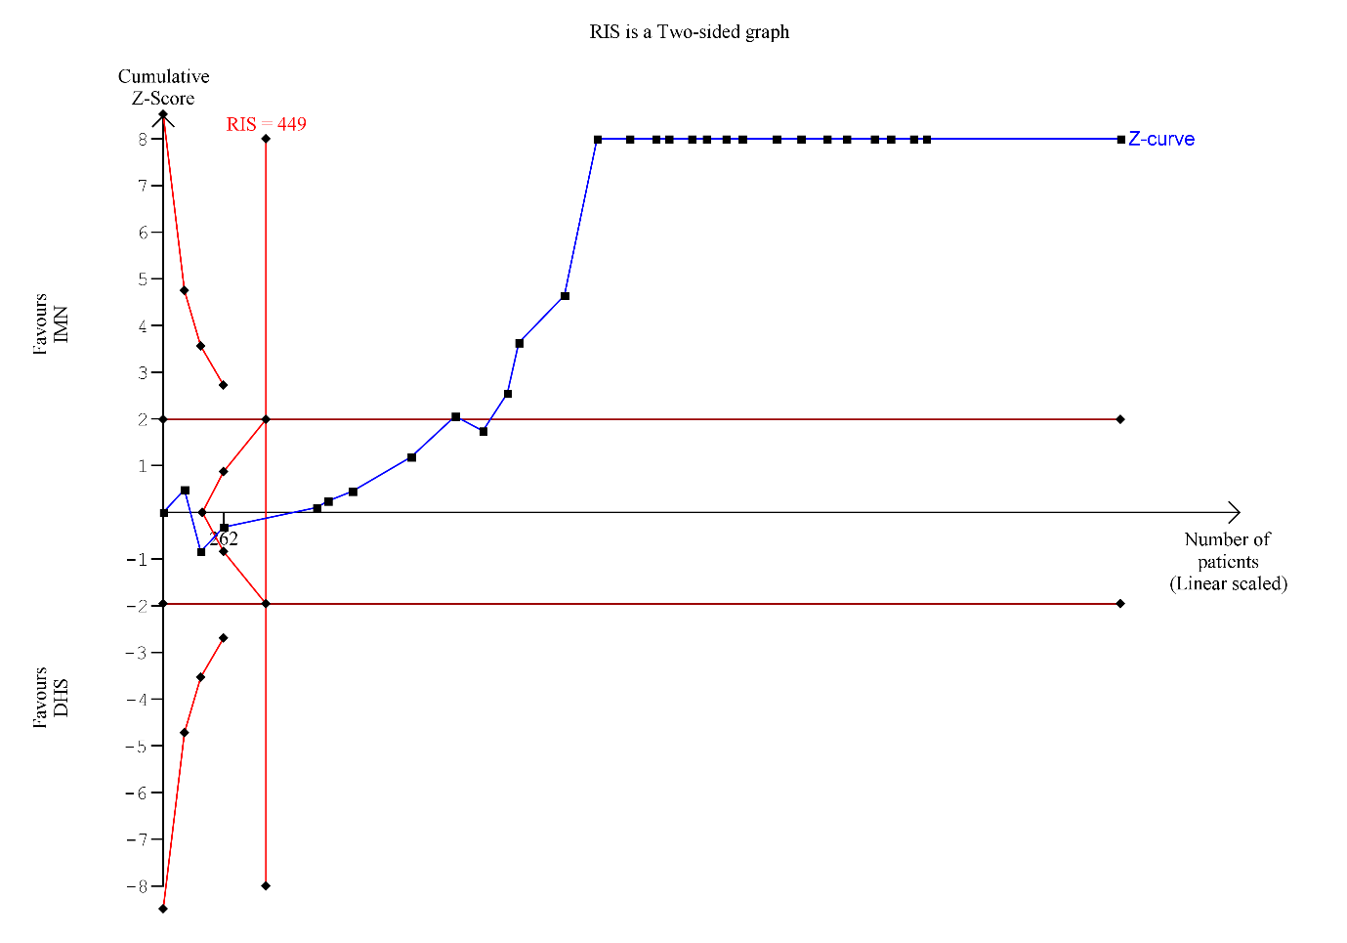
Supplementary Figure 13 Blood lose ml

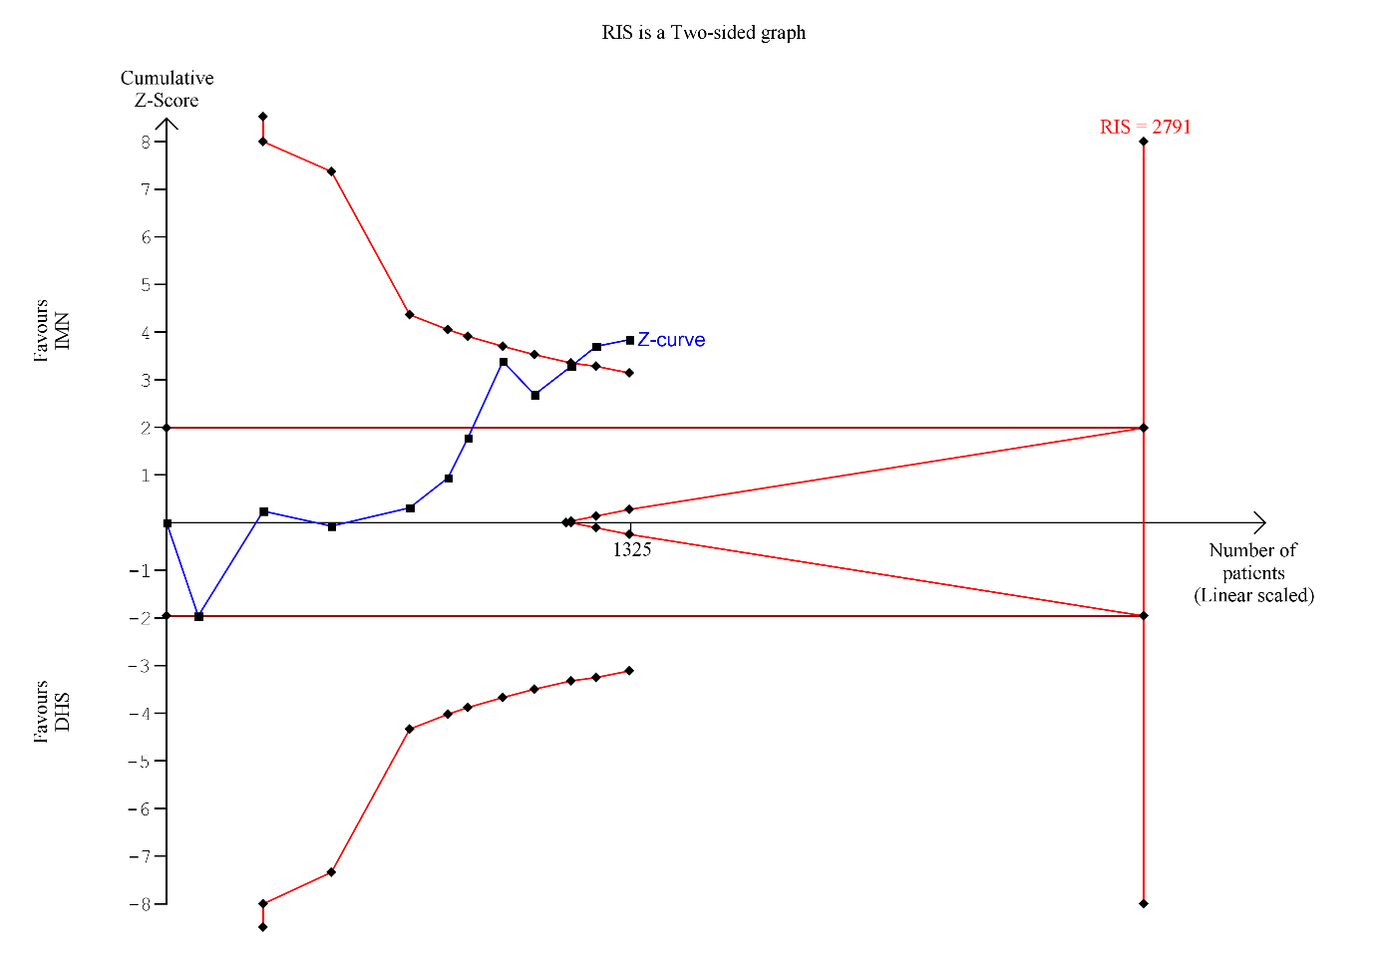
Supplementary Figure 14 time to healing (days)

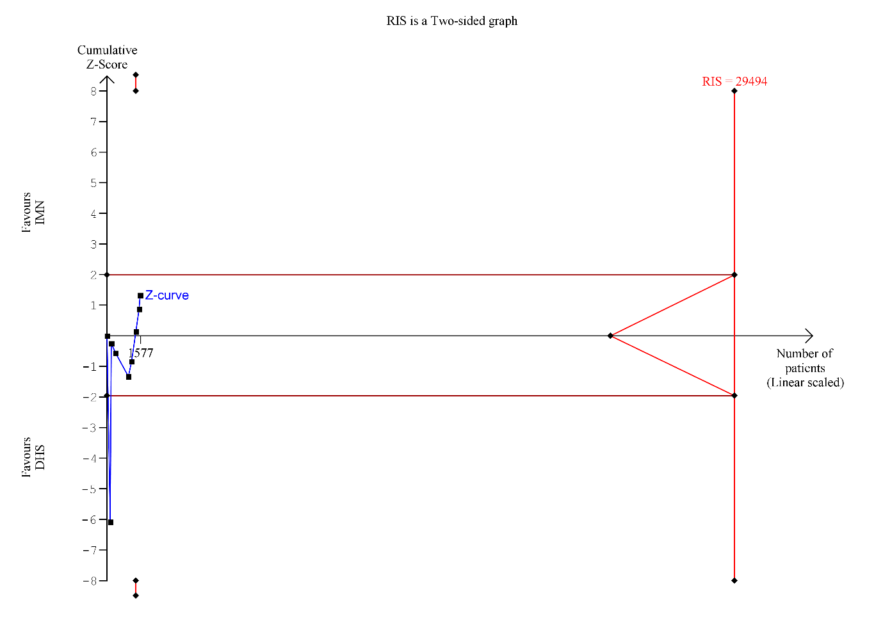
Supplementary Figure 15 femoral neck shortening (mm)

Publication bias (funnel plots)
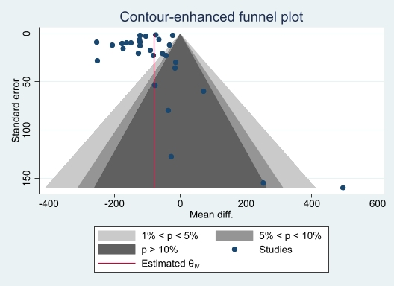
Supplementary Figure 16 Blood lose (ml)

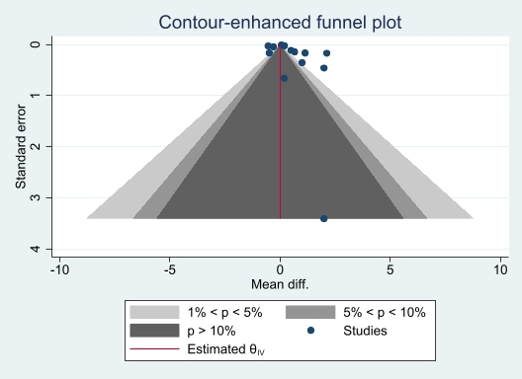
Supplementary Figure 17 Screening time (min)
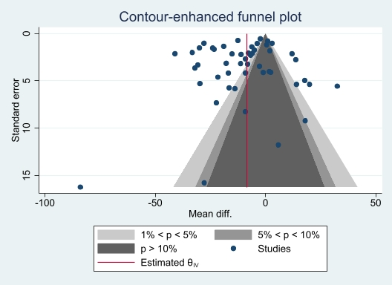
Supplementary Figure 18 Mean surgical time (min)
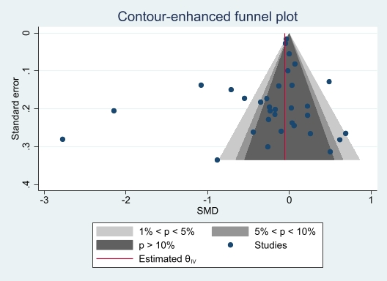
Supplementary Figure 19 hospital stay (days)
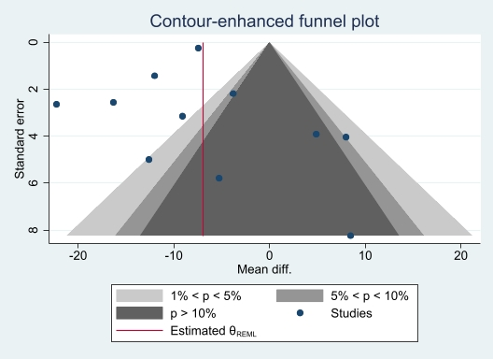
Supplementary Figure 20 time to healing (days)
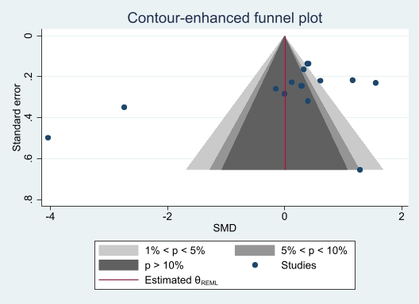
Supplementary Figure 21 mean Harris hip score

Supplementary Table 1: Meta-regression
Outcome | Meta regression
Outcome | Mean age | sex (male)
Open reduction of fracture | Coefficient = -.131  P value = 0.429 | Coefficient = -.014  P value = 0.645
Blood loss (ml) | Coefficient = 3.829  P value = 0.056 | NA
Patients needing blood transfusion | Coefficient = .070  P value = 0.481 | Coefficient = .000175  P value = 0.050
Required blood transfusion (Units) | Coefficient = .0538  P value = 0.225 | Coefficient = .000  P value = 0.974
Screening time (min) | Coefficient = .0124  P value = 0.840 | Coefficient = -.006  P value = 0.465
Mean surgical time (min) | Coefficient = .969  P value = 0.001 | NA
Hospital Stay (days) | Coefficient = .069  P value = 0.000 | NA
Time to Healing (days) | Coefficient = .628  P value = 0.129 | Coefficient = -.041  P value = 0.657
Femoral Neck Shortening (mm) | Coefficient = .364  P value = 0.250 | Coefficient = .007  P value = 0.876
Mean Harris Hip Score and Mobility | NA | NA
Parker Mobility Score | Coefficient = -.056  P value = 0.090 | Coefficient = -.001  P value = 0.831

